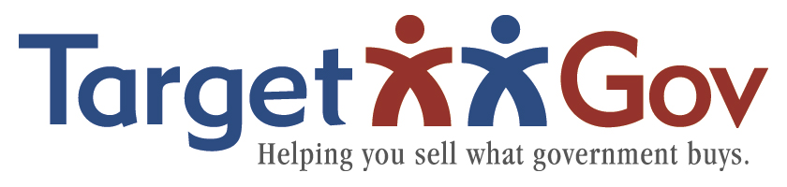

**How to Build a Keyword Resource**

**Document by Customer**

As explained within Section 1, the importance of the keywords cannot be overstated; these keywords are used within government systems searches, the SBA Dynamic Small Business Search (DSBS), the Search Engine Optimization (SEO) to ensure your organization is list first in the search results, and within your own marketing collateral, specifically, those materials directed toward targeted customer.

A keyword resource document should be created for each targeted customer. Once created, the keywords are used in the Capabilities Statement, Capabilities Brief, within the registration website, and all marketing messaging of the targeted customer.

In order to identify the keywords for the targeted customer, research the target customer. Visit their website, understand their mission and objectives; use keywords they use. Use [beta.SAM.gov](http://www.fbo.gov) or the agency’s website to identify past solicitations or awards issued by the agency within the NAICS your company intends to bid with each targeted customer.

Within these solicitations, use the customer provided background, objective, and performance work statement or scope of work to extract (by copying/pasting) keywords relevant to your company offerings.

Search the targeted customer in the news; determine their current hot topics in the news and see if any issues are relevant to your company offerings; if so, use the relevant keywords.

Keep the Keyword Resource Document as a “living document” adding new keywords and phrases as well as new targets.

Use the Keyword Resource Document template to ensure these keywords are communicated to your company business development, marketing, and external website administrators.

***FAST™* Process Keyword Resource Document**

| **NAICS or Keywords** | **Targeted Customer** | **Keywords** | **Where to be Used** |
| --- | --- | --- | --- |
| **SAMPLE:**  345123 123873 222453 | Department of Agriculture | Global food security, organic, farming, feed America, homegrown, micro-farming | USDA website registration, Capabilities Statement and Briefing, monthly customer contact, social networking tags |
|  | Agency name | Their specific keywords |  |
|  | Agency name | Their specific keywords |  |